BBVA Java Task Solution

Introduction:
For this task, the candidate is expected to demonstrate good software design and implementation within the context of low-latency systems. The solution provided is expected to be of reasonable quality for a prototype. Wherever the problem is unclear, the candidate should make (and state) any assumptions he or she thinks appropriate within the application context. Finally, although there is no time limit, this task is expected to take no longer than an hour.

The task:
Design and implement a Java “prototype” application that accomplishes the following:

- For each of i instruments, the application should subscribe for continuous market depth updates on m simulated market venues.
- The application should print out VWAP two-way prices for an instrument each time it receives a market depth tick for that instrument (from any market venue) in real-time.

Solution Design:

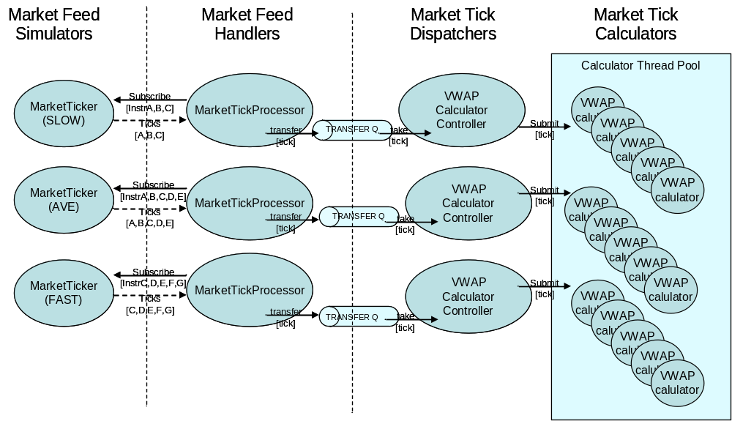

Implementation notes:
- All components circled above run in separate threads.
- Utilises JDK7.0 to leverage new TransferQueue as a means of providing automatic producer throttling.
- Limited testing due to time constraints.

Additional solution ideas:
- additional Q-based decoupling between Dispatchers and Calculators
- usage of priority-based Queues for high-priority Instruments
- add market feed handler throttling and conflation
- JVM and ThreadPool fine tuning

